BEVMAQ: The Platform Group launches online platform for beverage machines
Kaiserslautern, 11/24/2021
The Wiesbaden-based The Platform Group is expanding its platform business by founding BEVMAQ GmbH. The newly founded company, headquartered in Quakenbrück, Germany, specializes in the global trading of used machinery and equipment for the beverage industry.
The founders and managing directors of BEVMAQ are Carsten Hormes, former managing director of Wilhelm Hormes Ing. KG, and the two GINDUMAC founders, Janek Andre and Benedikt Ruf. Hormes brings industry knowledge and network to the company through his many years of experience at the family-owned plant manufacturer Wilhelm Hormes. Andre and Ruf, have shown with the GINDUMAC Group how to successfully establish platform business in the used machinery trading industry.
"Through GINDUMAC, we know that platform business works very well with machinery trading. We have been a majority shareholder there since 2020 and have seen very good development. With BEVMAQ, we want to do the same in the beverage industry. We have put together a strong team for this," says Dr. Dominik Benner, CEO of The Platform Group.
BEVMAQ offers sellers and buyers of used machinery and equipment an all-round carefree package, ranging from purchasing and machine documentation to transport and installation.
"Global marketing, best possible purchase price and professional pick-up are essential. Transparent documentation, fair prices, and full transaction management make us unique in the market. In the non-transparent and fragmented used machinery market, we thus offer a long-awaited added value for the beverage industry," adds Carsten Hormes, Managing Director - Engineering of BEVMAQ GmbH.
The company's own online platform at www.bevmaq.com will play a central role in the future.

About BEVMAQ:
BEVMAQ specializes in the global trading of used machinery in the beverage industry. With its machine platform www.bevmaq.com, the company offers full transaction management for sellers and buyers of used machines. BEVMAQ was founded at the end of 2021 by The Platform Group GmbH & Co. KG, Carsten Hormes (former managing director of Wilhelm Hormes Ing. GmbH & Co. KG), Janek Andre and Benedikt Ruf (founder and managing director of the GINDUMAC Group).
About The Platform Group:
The Platform Group (www.the-platform-group.com) is a group of companies from Wiesbaden, Germany, invests in platform technology companies and is invested in 14 industries. Important portals include Gindumac, Bike-Angebot, Lott-Fahrzeugteile, Schuhe24 and Dein-Juwelier. In 2021, a volume of over 200 million euros will be realized with 300 employees.

Press Images
IMG_BM_Gruenderteam.jpg
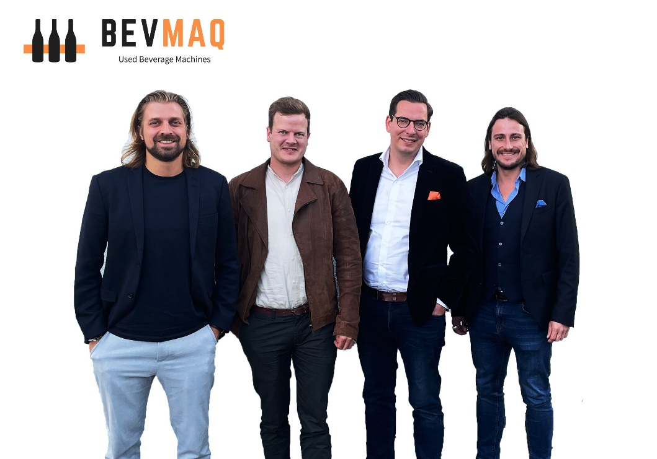
The founding and management team of BEVMAQ. From left to right: Janek Andre, Carsten Hormes, Dr. Dominik Benner and Benedikt Ruf.

Press Contact
Benedikt Ruf
Managing Director - Marketing
T: +49 173 273 1973
E: b.ruf@bevmaq.com
BEVMAQ GmbH
Mühlenhorst 8
49637 Menslage

